ZoneDirector Migration Script

Contents

Preparing the environment 2

Unblock Zip Folder 2

To Unblock and Extract 2

Enable PowerShell RemoteSigned Execution 3

Change Execution Policy 3

Use PowerShell ISE 4

What You Will Need 5

To Cloud 5

To SmartZone 6

Current Capabilities 6

To Cloud 6

To SmartZone 7

How to Run Migration Script 7

Execution Policy Set 7

PowerShell ISE 8

# Preparing the environment

## Unblock Zip Folder

PowerShell is Microsoft’s new cross-platform task automation command line shell replacing CMD (command prompt). Multiple tasks in a Window’s or Linux environments can be automated through PowerShell script files (.ps1 or .psm1). This script must temporarily upload dlls to the running PowerShell session for it to work.

When zip folders and files are downloaded from the internet, Windows blocks them initially. This is to prevent them from being able to download or install anything on the system. Since the script needs to temporarily upload files to the running PowerShell session, the zip folder needs unblocked before extracting files.

### To Unblock and Extract

1. Go to where the script files were downloaded, right click on folder, select properties
2. At the bottom of the General tab, select Unblock, and click Apply

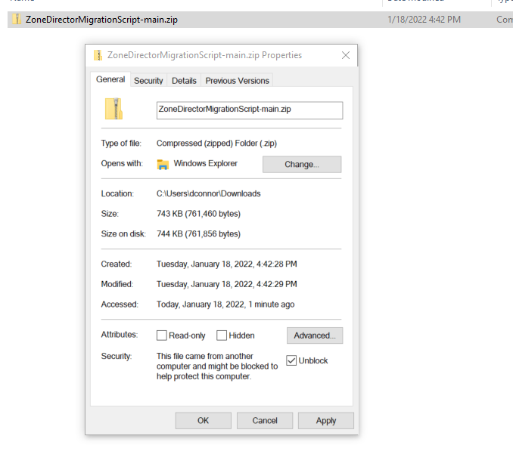

1. Extract all from the folder

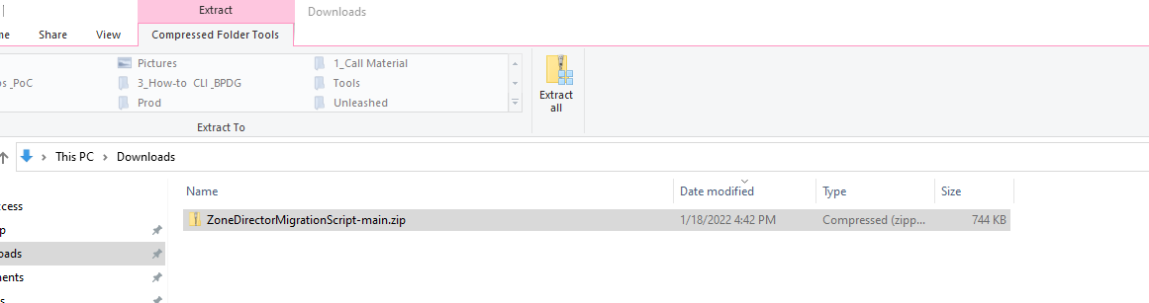

## Enable PowerShell RemoteSigned Execution

PowerShell is Microsoft’s new cross-platform task automation command line shell replacing CMD (command prompt). Multiple tasks in a Window’s or Linux environment can be automated through PowerShell script files (.ps1 or .psm1).

PowerShell script files can be written by Microsoft, individual companies, or hobbyist. To run a script in PowerShell, the script must be digitally signed. This is to prevent email attachments or internet downloads from running scripts on the device without knowing where it came from.

Since this script isn’t digitally signed, either the PowerShell Execution policy needs changed to RemoteSigned temporarily or the script needs to be run in PowerShell ISE.

### Change Execution Policy

1. You will need administrator privileges on your device to perform these steps. If those privileges are set, move to Use PowerShell ISE.
2. In the Windows menu, type PowerShell and click Run As Administrator

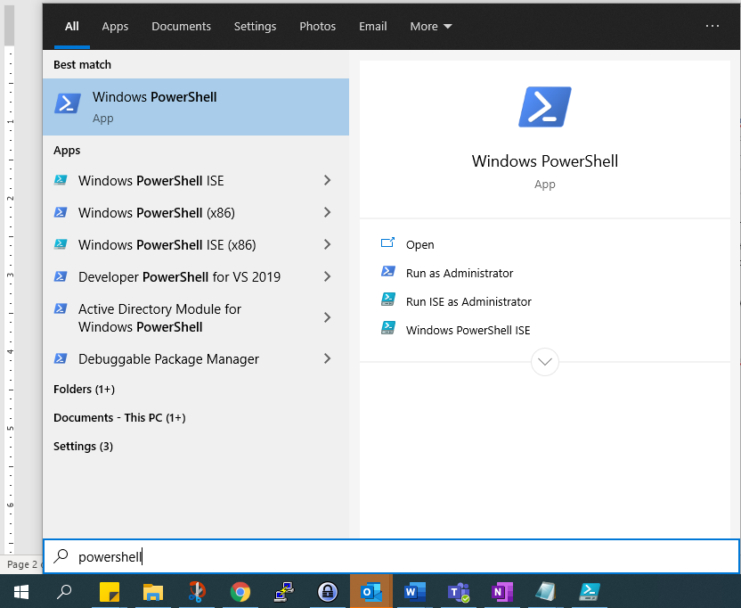

1. Run the command: **Get-ExecutionPolicy -List**
   1. I recommend taking a picture or writing down the current settings to change them back after the migration is complete

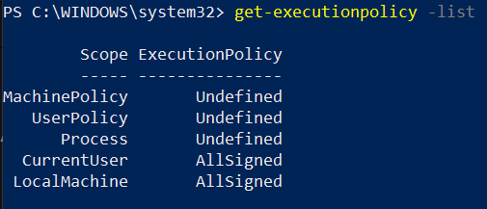

1. If CurrentUser or LocalMachine doesn’t say RemoteSigned run the below commands
   1. **Set-ExecutionPolicy -Scope CurrentUser -ExecutionPolicy RemoteSigned**
   2. **Set-ExecutionPolicy -Scope LocalMachine -ExecutionPolicy RemoteSigned**
   3. **Get-ExecutionPolicy -List**

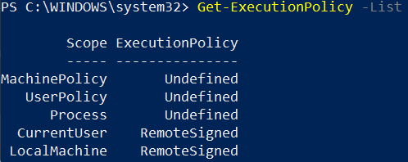

1. Close out of the PowerShell Terminal
2. After done migrating, return here and set the execution policy back to its original settings

### Use PowerShell ISE

1. In the unzipped downloaded location of the migration files, right click on ZoneDiretorMigration.ps1 and select edit.

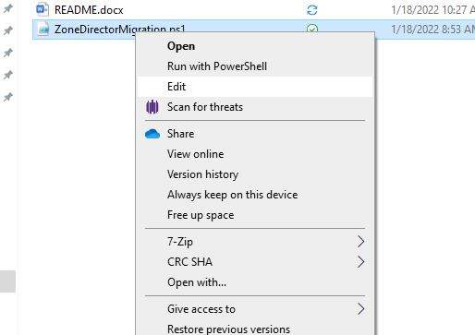

1. The PowerShell Integrated Scripting Environment should now be open.
   1. 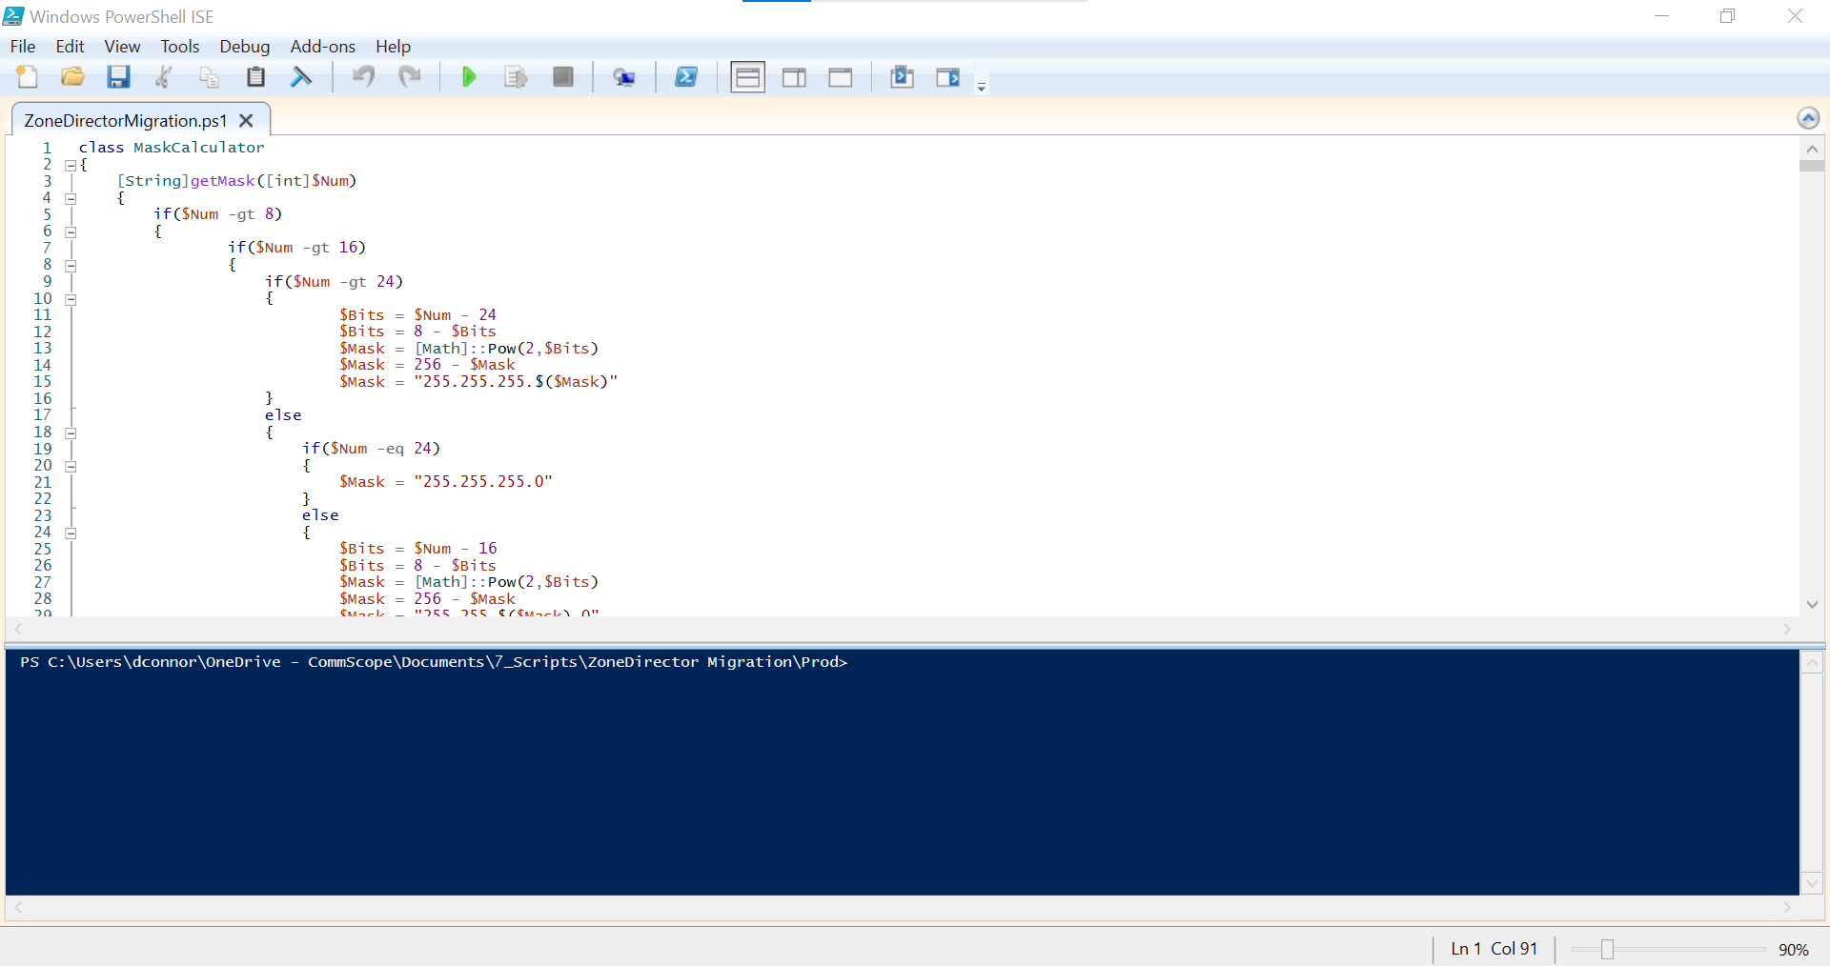

# What You Will Need

## To Cloud

* SSH network access to ZoneDirector controller
* SSH network access to all ZoneDirector APs
* HTTPS network access to Cloud controller
* admin username and password for ZoneDirector controller
* admin username and password for Cloud controller (Prime User)
* cloud licenses need to be activated on Cloud Controller
* **\*\*** if AAA serveries are configured, know if it is Cloudpath SaaS, Cloudpath on-premise, or third-party AAA server
* **\*\*** if DPSK is configured, download DPSK key list from ZoneDirector controller and upload to DPSKs folder
  + To download the DPSK key list
    - Login to the ZoneDirector
    - Go to Wireless LANs > Dynamic PSK Batch Generation > To download all

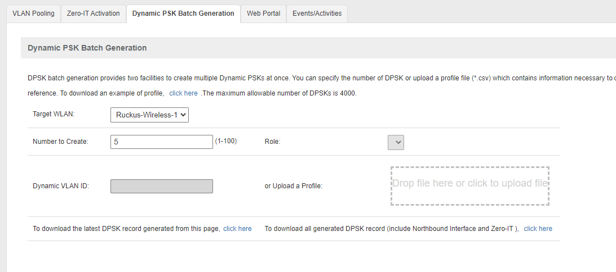

* + - Place downloaded file in the migration folder called DPSKs

## To SmartZone

* Code not completed Yet

# Current Capabilities

## To Cloud

* Networks
  + IPv4
* AP
  + Serial Number
  + **Note:** This only puts the AP serial number into the Cloud and doesn't fully migrate the APs. Another step outside of the script needs to be performed to full migrate APs to Cloud.
* WLANs
  + WLAN Usages
    - Standard Usage
    - Authentication
    - Open
    - 802.1x EAP: RADIUS Only
    - MAC Address
    - Dynamic-PSK (DPSK): Internal and External
    - Fast BSS Transition (802.11r)
  + Encryption
    - WPA2
    - WPA3
    - WPA2/WPA3-Mixed
    - WPA-Mixed
    - WEP-128
    - None
    - Algorithm AES
    - Passphrase, SAE Passphrase, and WEP Key HEX
  + Advanced Options
    - Name
    - ESSID
    - Description
    - 802.11w MFP
    - Client Isolation
    - Access Control
    - L2/MAC
    - L3/4/IP address
    - Rate Limiting
    - SSID Rate Limiting
    - VLAN Pooling
    - Access VLAN
    - Hide SSID
    - Proxy ARP
    - Background Scanning
    - Load Balancing
    - Max Clients
    - Force DHCP
    - DIRECTED MC/BC Threshold
    - OFDM Only
    - BSS Min Rate
    - Mgmt. Tx Rate
    - Inactivity Timeout
    - Radio Resource Management (802.11k)
    - Transient Client Management
* AAA Services
  + Type: RADIUS
    - Primary and Secondar RADIUS
* Access Control
  + L2/MAC
  + L3/4/IP address
* VLAN Pools
* DPSK User and Passwords

## To SmartZone

* Code not completed Yet

# How to Run Migration Script

## Execution Policy Set

1. In the migration folder, right click on the ZoneDirectorMigration.ps1 file and select Run with PowerShell

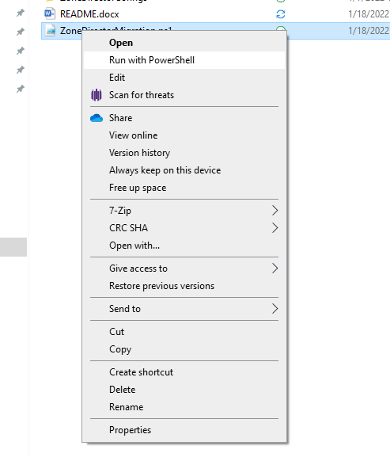

## PowerShell ISE

1. In the PowerShell ISE window, click the green play button.

